RECYCLED AGGREGATE CONCRETE

.

M.PRIYANKA R.PAVITRA REDDY

DCE I year II SEM DCE I year II SEM

DEPARTMENT OF CIVIL ENGINEERING DEPARTMENT OF CIVIL ENGINEERING ENGINEERING

SREE VISVESVARAYA INSTITUTE OF SREE VISVESVARAYA INSTITUTEOF

TECHNOLOGY AND SCIENCE TECHNOLOGY AND SCIENCE

**ABSTRACT:**

Use of recycled aggregate in concrete can be useful for environmental protection. Recycled aggregates are the materials for the future. The application of recycled aggregate has been started in a large number of construction projects of many European, American, Russian and Asian countries. Many countries are giving infrastructural laws relaxation for increasing the use of recycled aggregate. This paper reports the basic properties of recycled fine aggregate and recycled coarse aggregate & also compares these properties with natural aggregates. Basic changes in all aggregate properties are determined and their effects on concreting work are discussed at length. Similarly the properties of recycled aggregate concrete are also determined. Basic concrete properties like compressive strength, flexural strength, workability etc. are explained here for different combinations of recycled aggregate with natural aggregate. Codal guidelines of recycled aggregates concrete in various countries are stated here with their effects, on concreting work. In general, present status of recycled aggregate in India along with its future need and its successful utilization are discussed here.

**INTRODUCTION**

**Need for Recycled Aggregate:-**

**facilities.** Urbanization growth rate in India is very high due to industrialization. Growth rate of India is reaching 9% of GDP. Rapid infrastructure development requires a large quantity of construction materials, land requirements & the site. For large construction, concrete is preferred as it has longer life, low maintenance cost & better performance. For achieving GDP rate, smaller structures are demolished & new towers are constructed. Protection of environment is a basic factor which is directly connected with the survival of the human race. Parameters like environmental consciousness, protection of natural resources, sustainable development, play an important role in modern requirements of construction works. Due to modernization, demolished materials are dumped on land & not used for any purpose. Such situations affect the fertility of land. As per report of Hindu online of March 2007, India generates 23.75 million tons demolition waste annually. As per report of Central Pollution Control Board (CPCB) Delhi, in India, 48million tons solid waste is produced out of which 14.5 million ton waste is produced from the construction waste sector, out of which only 3% waste is used for embankment. Out of the total construction demolition waste, 40% is of concrete , 30% ceramic‟s, 5% plastics, 10% wood, 5%metal, & 10% other mixtures. As reported by global insight, growth in global construction sector predicts an increase in construction spending of 4800 billion US dollars in 2013. These figures indicate a tremendous growth in the construction sector, almost 1.5 times in 5 Years. For production of concrete, 70-75% aggregates are required. Out of this 60-67% is of coarse aggregate & 33-40% is of fine aggregate. As per recent research by the Fredonia group, it is forecast that the global demand for construction aggregates may exceed 26 billion tons by 2012. Leading this demand is the maximum user China 25%, Europe 12% & USA 10%, India is also in top 10 users. From environmental point of view, for production of natural aggregates of 1 ton, emissions of 0.0046 million ton of carbon exist where as for 1ton recycled aggregate produced only 0.0024 million ton carbon is produced. Considering the global consumption of 10 billion tons/year of aggregate for concrete production, the carbon footprint can be determined for the natural aggregate as well as for the recycled aggregate. The use of recycled aggregate generally increases the drying shrinkage creep & porosity to water & decreases the compression strength of concrete compared to that of natural aggregate concrete. It is nearly 10-30% as per replacement of aggregate. Recycling reduces the cost (LCC) by about 34-41% & CO2 emission (LCCO2) by about 23-28% for dumping at public / private disposal.

**What Are Aggregates?**

Aggregates are used in the making of concrete

Concrete is composed of water, cement paste, coarse aggregates, fine aggregates, and admixtures

Aggregates help the strength of the concrete by filling in void spaces and resisting compressive stress**.**

**Why Should We Use Recycled Aggregates?**

Recycled aggregates are a way of reusing materials by keeping them from being disposed into landfills

They are more cost efficient than most regular aggregates

Recycled aggregates lower the amount of energy and raw materials used for the production of it.

**Production**

Each and every aggregate is produced differently

Our group chose to focus on 4 main types of sustainable aggregates

Recycled Concrete

Poraver

Granulated Blast Furnace Slag.

**Recycled Concrete Production:**

Simple process involving breaking removing and crushing concrete into specified size and quality (sold at a size of 37.5mm – 50mm)

Reinforcing steel and other embedded items must be removed before the quality of the aggregate can be produced

Removal of contaminants is achieved by demolition, screening or air separation, and reduction of size.

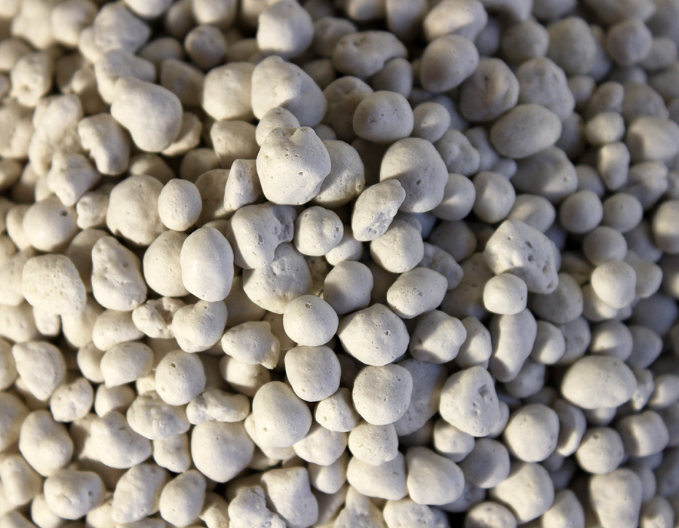

**Ground Granulated Blast Furnace Slag Production:**

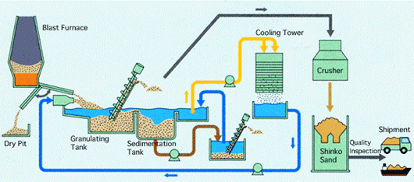



**Advantages of Recycled Aggregates:**

1. **Recycled Concrete**

2. Provides sustainability

3. Reduces the amount of material that would be delivered to a landfill

4. Any metals that can be removed from the aggregate can be disposed properly

5.Reduces the need of virgin aggregates to be created

6. Absorbs large amount of carbon dioxide while being crushed into smaller sizes, reduces the amount of CO2 in the atmosphere.

**Poraver :**

1. Highly heat insulating
2. Low weight and high compressive strength
3. Resistant to chemical and alkaline attack
4. Excellent thermal and sound resistant properties
5. Inflammable and weather resistant
6. Does not provide a breeding ground for bacteria and mold.

**Granulated Blast Furnace Slag :**

1. Uses 90% less energy in production than the production of portland cement
2. Emission of carbon dioxide is almost negligible
3. Provides improved strength and durability
4. Reduces permeability
5. Improves workability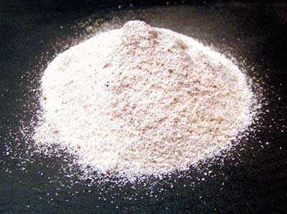

**Concrete Canoe:**

50% of the total amount of aggregate by weight must come from sustainable aggregates

Last week the mix design team

picked our final mix to use pelletized milk jugs and cenospheres as our recycled aggregate based

**Objectives of the study:-**

To find out the % use feasible for construction.

• To reduce the impact of waste materials on environment.

• To carry out different tests on recycled aggregates & natural aggregates & compare their results.

• To find out the ways of cost saving such as transportation, excavation etc.

**Methodology:-**

Plain cement concrete (PCC) & reinforce cement concrete is collected from sites (i.e. Sri SavitribaiPhule Polytechnic, Pune &MangaolGrampanchyat School, Mongol, Haveli, Pune) respectively. This collected material is crushed by hammer to separate the aggregates & reduce their sizes in smaller fraction. On these separated aggregates various testes are conducted in laboratory as per Indian Standard code & their results are compared with natural aggregates. Recycled aggregate reduces the impact of waste on environment. By using some percentage in construction sector, cost is saved, due to reduction of transportation & manufacturing process.

**TESTS ON RECYCLED AGGREGATE :-**

Demolished material of reinforced cement concrete (RCC) & PCC is used for recycling in foundation. The life of RCC demolish material is 25 yrs. Such mated crushing, sieving & separation process are done by manual crushing method. On demolish material, aggregate tests are conducted which are mentioned in Indian Standard code for natural aggregate & check feasibility.

**Properties of Recycled Concrete Aggregate:-**

**Particle Size Distribution:-**

|  |  |  |  |  |  |
| --- | --- | --- | --- | --- | --- |
| **Table 1:-** SR.NO. | | PARTICULARS | | VALUES | |
| Natural Aggregate | | | Recycled Coarse Aggregate | | |
| 1 | Specific Gravity | | 2.4-3.0 | | 2.35-2.58 |
| 2 | Water Absorption | | 0.29%-0.3% | | 0.3%-0.32% |
| 3 | Bulk Density | | 1678.2 KN/m3 | | 1469.8KN/m3 |
| 4 | Crushing Values: | | 18.4% | | 36.3% |
| 5 | Impact Values: | | 17.65% | | 35.2% |

Sieve analysis is carried out as per IS 2386 for crushed recycled concrete aggregate and natural aggregates. It is found that recycled coarse aggregate are reduced to various sizes during the process of crushing and sieving, which gives the best particle size distribution. The amounts of fine particles less than 4.75mm after recycling of demolished waste were in the order of 5-20% depending upon the original grade of demolished concrete. The best quality natural aggregate can be obtained by primary, secondary & tertiary crushing, whereas the same can be obtained after primary & secondary crushing incase of recycled aggregate. The single crushing process is also effective in the case of recycled aggregate. The particle shape analysis of recycled aggregate indicates similar particle shape of natural aggregate obtained from crushed rock. The recycled aggregate generally meets all the standard requirements of aggregate used in concrete.

**Specific Gravity:-** The specific gravity in saturated surface dry condition of recycled concrete aggregate was found from 2.35 to 2.58 which are less but satisfying the results. If specific gravity is less than 2.4, it may cause segregation, honeycombing & also yield of concrete may get reduced.

**Water Absorption:-** The RCA from demolished concrete consist of crushed stone aggregate with old mortar adhering to it, the water absorption ranges from 1.5% to 7.0%, which is relatively higher than that of the natural aggregates. Thus the water absorption results are satisfactory.

Bulk Density The bulk density of recycled aggregate is lower than that of natural aggregate, thus results are not satisfactory; due to less Bulk Density the mix proportion gets affected.

**Crushing and Impact Values** The recycled aggregate is relatively weaker than the natural aggregate against different mechanical actions. As per IS 2386 part (IV), the crushing and impact values for concrete wearing surfaces should not exceed 30% & for other than wearing surfaces 45% respectively. The crushing & impact values of recycled aggregate satisfy the BIS specifications limit. From crushing & impact test it is found that use of recycled aggregate is possible for application other than wearing surfaces.

**Compressive test on cubes**

The average compressive strengths of cubes cast are determined as per IS 516 using RCA and natural aggregate at the age 3, 7, & 28days and reported in Table2. As expected, the compressive strength of RAC is slightly lower than the conventional concrete made from similar mix proportions. The reduction in strength of RAC ascompare to NAC is in order of 8-14% and 10-16%for M-30 & M-40 concretes respectively. The amount of reduction in strength depends on parameters such as grade of demolished concrete, replacement ratio, w/c ratio, processing of recycled aggregate etc. As per test results the strength of recycled aggregate cube is more than target strength, so RCA can be used for construction purpose.

**Compressive strength:-**

|  |  |  |  |  |  |  |  |
| --- | --- | --- | --- | --- | --- | --- | --- |
| Compressive Strength | | | | Replacement Of Natural Aggregate | | | |
| 0% | | 10% | | 20% | | 30% | |
| M30-3Days | 20.63 N/mm2 | | 16.38 N/mm2 | | 19.05 N/mm2 | | 18.46 N/mm2 |
| M30-7 Days | 33.13 N/mm2 | | 23.83 N/mm2 | | 31.93 N/mm2 | | 28.05 N/mm2 |
| M30-28 Days | 47.53 N/mm2 | | 42.28 N/mm2 | | 43.92 N/mm2 | | 40.27 N/mm2 |
| M40-3 Days | 31.59 N/mm2 | | 28.44 N/mm2 | | 27.56 N/mm2 | | 25.78 N/mm2 |
| M40-7 Days | 56.67 N/mm2 | | 53.69 N/mm2 | | 51.69 N/mm2 | | 49.78 N/mm2 |
|  |  | |  | |  | |  |
| M40-28 Days | 64.42 N/mm2 | | 60.44 N/mm2 | | 56.22 N/mm2 | | 54.22 N/mm2 |
|  |  | |  | |  | |  |
|  |  | |  | |  | |  |

**CONCLUSIONS:-**

1. Use of recycled aggregate up to 30% does not affect the functional requirements of the structure as per the findings of the test results.

2. Various tests conducted on recycled aggregates and results compared with natural aggregates are satisfactory as per IS 2386.

3. Due to use of recycled aggregate in construction, energy & cost of transportation of natural resources & excavation is significantly saved. This in turn directly reduces the impact of waste material on environment.